

PUNJAB MUNICIPAL
DEVELOPMENT FUND COMPANY

PUNJAB MUNICIPAL SERVICES IMPROVEMENT PROJECT (PMSIP)

PLANNING REPORT
FATEH JANG

November 2007
TABLE O F CONTENTS
Chapter I
Introduction |  | 1
 | 1.1 Background | 1
 | 1.2 PMSIP Planning | 1
 | 1.3 Limitations of PMSIP Planning | 2
 | 1.4 The Planning Process | 2
 | 1.5 Methodology | 4
Chapter II
Profile of Fateh Jang |  | 6
 | 2.1 General | 6
 | 2.2 Location | 6
 | 2.3 Area/Demography | 6
Chapter III
Institutional Analysis of TMA Fateh Jang
 | 3.1 Capacity Building at TMA Fateh Jang | 8
 | 3.2 PMSIP Computer Trainings | 8
 | 3.3 Hands on Trainings for Complaint Resolution | 9
 | 3.4 Performance Management System | 9
 | 3.5 Financial Management System | 11
 | 3.6 Management Analysis | 13
Chapter IV
Urban Planning
 | 4.1 TO(P) Office | 14
 | 4.2 Mapping | 14
 | 4.3 Land use Characteristics | 16
 | 4.4 City Zones | 17
 | 4.5 Housing Typologies | 17
 | 4.6 Growth Directions | 18
Chapter V
Status of Municipal Infrastructure & Recommendations |  | 19
 | 5.1 Road Network | 19
 | 5.2 Water Supply | 20
 | 5.3 Sewerage | 25
 | 5.4 Street Lights | 29
 | 5.5 Solid Waste Management | 29
 | 5.6 Fire Fighting | 35
 | 5.7 Parks | 38
 | 5.8 Slaughter House | 40
Chapter VI
Workshop on Prioritization of Infrastructure Sub-Projects |  | 44
 | 6.1 Pre-Workshop Consultations | 44
 | 6.2 Workshop Proceedings | 44
 | 6.3 Prioritized List of Sub-Projects | 46
Annexes
 | Annex-A Road Data | 48
 | Annex-B Water Supply Data | 49
 | Annex-C Sewerage Data | 51
 | Annex-D Solid Waste Data | 52
LIST OF TABLES

Table 1: Population forecast for Fateh Jang
Table 2: Staff Trained under PMSIP
Table 3: The details of Workshops / Seminars in which TMA Fateh Jang was invited
Table 4: Baseline Information provided by TMA
Table 5: Detail of Posts in Planning Department (TMA-Fateh Jang)
Table 6: Type of Housing Structures
Table 7: Housing Facilities
Table 8: Detail of Main Road Junctions in Fateh Jang
Table 9: Major TMA Roads
Table 10: The proposed road for reconstruction
Table 11: Technical Details of Intermediate Pumping Station
Table 12 : Details Of Existing Water Storage Tanks
Table 13: Water Tariff Collection and Expenditure

Table 14: Sub-Project Proposal
Table 15: Demand for Service
Table 16: Sub-Project Proposal
Table 17: Proposal
Table 18: Proposal for Parks
Table 19: Prioritized Projects- Fateh Jang

LIST OF EXHIBITS

- Base map
- Land use map
- Solid waste map
LIST OF MAPS

Chapter I

INTRODUCTION

1.1 Background

Planning is now a part of Punjab’s local government system with the planning responsibilities of TMAs, clearly set out in PLGO. Under the devolved system, the newly created office of TO(P) has the following functions to perform; (i) develop plans; (ii) develop and apply building controls; (iii) manage CCBs; (iv) implement commercialization rules; (v) operate Punjab housing development schemes; (vi) develop site development schemes. In addition, The PLGO identifies the preparation of spatial plans (Article 54 a), development plans (Article 54 c) and budget plans, long term and annual municipal development programs (Article 54 j) as key functions of the TMAs. Unfortunately, in majority of TMAs TO(P) office has not been able to perform as envisioned in the PLGO. Some of the reasons are inadequately skilled staff and lack of up-to-date maps, necessary equipment and management/ regulation/ and enforcement mechanisms. As a result, development works are taking place in a piecemeal manner and lack integrated and coordinated approach.

Punjab Municipal Development Fund Company (PMDFC) was established by the Government of the Punjab as a specialized organization to help improve the municipal service delivery in Punjab. For this purpose Punjab Municipal Services Improvement Project (PMSIP) was launched in July 2006 with the funding of World Bank. PMSIP envisages an integrated approach to development for which planning is an integral part.

1.2 PMSIP Planning

The PMSIP thus aims at institutional development of TMAs through improving systems directly related to their functions and through investments in service delivery. This objective will be achieved by granting eligible TMAs both capacity grants and development grants. The World Bank and the Government of Punjab are funding the Project.

Apart from providing funds for improvement and development of municipal infrastructure, the key initiative of PMSIP is to assist TMAs in developing their institutional capacity by providing management support tools like GIS, computerization of TMA functions, testing laboratory equipment, trainings, establishment of performance management systems etc.

The most catching feature of the planning exercise is the involvement of the stakeholders. The objective behind their involvement was to endorse of the prioritized list by the ones for whom it was prepared.

The Planning exercise is a comprehensive account for the TMA to identify sectors for efficient allocation of resources on one hand and enhancing their capacity to run the projects, on the other hand. This process is hence the amalgamation of technical inputs and the aspiration of the stakeholders.

1.3 Limitations of PMSIP Planning

The PMSIP development grants fund municipal services only. PMSIP planning exercise is undertaken at CO Units starting from CO Unit HQ. The prioritized list that is developed is restricted to the UCs falling in CO Units. Hence the PMSIP planning is not for the entire TMA as it does not take into account the rural area of a TMA. PMSIP planning ends at the preparation of prioritized list.

1.4 The Planning Process

The PMSIP Action planning process is a short term process for the rapid assessment/identification of infrastructure projects.

The Planning Report for Fateh Jang has been prepared by active participation of all stakeholders including elected representatives, UC Nazim, Naib Nazim, councilors, and TMA officials through meetings, discussions, formal & informal interviews and workshop.

To involve the stakeholders in the planning process, PMDFC made entry point through meetings with Tehsil Nazim and formulation of Working Groups. Frequent Meetings were also held with the TMA officials including Tehsil Municipal Officer (TMO) and the Tehsil Officers (TOs), particularly TO (P&C) and TO (I&S). PMDFC planning team worked very closely with second line officials of the TO(I&S) office to collect the service delivery data through pre designed forms.

For socially acceptable and sustainable planning, it was important to understand the priorities, living styles, attitude, norms, gender sensitivity, and perceptions of people about their community and physical development. PMDFC therefore, where possible, ensured informal consultations and information sharing with the common man.

Apart from consultations with the stakeholders, data relating to urban planning and infrastructure (both secondary and primary) was also collected for analysis and preparation of technical list of sub-projects. The available information through secondary sources was collected through various documents and publications of the Government, TMA records, and other development partners. In addition, GIS map of Fateh Jang was procured by PMDFC and data layers were developed. This proved to be a powerful tool for spatial analysis, identification of deficiencies in different sectors, and identification of projects.

The projects identified on technical grounds were then presented in a Stakeholders Consultative Workshop for validation and prioritization. The capacity building projects were finalized on basis of consultations with Tehsil Nazim, TMO and other officials. The planning process is summarized in the following flow chart.
Data Analysis
PLANNING PROCESS

Institutional arrangements
Visioning by Nazim
Formation of
Working Groups

Urban Planning
Surveys
Identification of Infrastructure Projects
TMA Institutional Analysis

Landuse Surveys

Development of Database in GIS

Infrastructure surveys

Prioritized list of sub Projects
Up-dating Base Map

Prioritization of Projects in Workshop

Fig 1: Flow chart for Planning Process
1.5 Methodology

A bottom up planning approach has been adopted to derive a list of projects for the TMA. In this process the political leadership and the community has a significant role, for which the development is meant for.

The prioritized list of projects would facilitate the TMA to make investment decisions. This list was developed through a comprehensive exercise of data collection and analysis, the results of which were then presented before the stakeholders in the form of a list of infrastructure sub-projects to prioritize.

Sources of Data

In general, there were two sources for data collection:
- Primary source
- Secondary sources

Primary Source

The methodology for the collection of data was to verify the available information with the TMA and PMDFC in the field surveys. However, much of the information was added by actually taking the observations in the field. For example for solid waste management data for secondary collection points was collected.

Secondary Sources

The secondary sources for data collection were TMA record, District Census Report, information from PHED, Housing and Physical Planning department, PMDFC Field Appraisal Report (FAR), Feasibilities produced by PMDFC etc.

Primary data collected by the PMDFC under its flagship Institutional Development intervention, Performance Management System (PMS) was a good starting point. Under PMS road rating surveys were conducted, the results of which were used and further verified and updated. Similarly park and sanitation connections surveys were useful source of information as well as the information in respect of water supply, solid waste collection and street light collected and consolidated by TMA on the forms developed and provided by the PMDFC.

Visioning

The whole planning process stems from Nazim’s vision for identification of development projects. Therefore, a preliminary meeting was held by PMDFC with the Tehsil Nazim in order to shape his vision statement which was then communicated to all of the stakeholders in the planning process. (What was that vision statement?) PMDFC discussed the prospects of the planning process with the Nazim and translated his vision in concrete and tangible targets.
Therefore, the Nazim was involved right from the beginning of the planning process until the prioritized list was developed.

At the end of the planning process, another meeting was conducted with the Nazim in which whole planning process was reviewed in the light of actual field experiences, ground realities and all those issues that were not visualized at the start of the planning process.

Interviews with the Focused Groups/Stakeholders

To assess the overall situation of TMA Fateh Jang, PMDFC held interviews with stakeholders, i.e. UC Naib Nazims, member of Tehsil council and NGOs.

Formation of the Working Group

A working group comprising of second line officials from the planning and I&S offices worked very closely with the planning professionals from PMDFC in the preparation of the plan.

Prioritization Workshop

The list that was developed based on technical recommendation by PMDFC was then presented before the stake holders including Nazim, UC Nazim, Naib Nazim, councilors, etc, as they were the best to determine their priorities. This exercise was done in a workshop, arranged by PMDFC, where the service delivery needs in the existing system, together with costs, advantages, disadvantages of the development projects were presented and discussed with the stake holders.

Chapter II

PROFILE OF FATEH JANG

2.1 General

TMA Fateh Jang is one of the five TMAs of District Attock. There are 14 Union Councils in the tehsil out of which only 2 fall in urban areas/CO units. The TMA has only one CO unit, Fateh Jang.

2.2 Location

Fatehjang town is located in district Attock and is TMA Fatehjang headquarter. It is located at a distance of 50 kms from Islamabad on Islamabad-Kohat road and 48 kms from Attock city. It is connected to other cities like Talagang, Rawalpindi and Kohat through roads and railways. The location map of the town is available at Annex A.

2.3 Area/Demography

According to 1998 Population and Housing Census, total population and urban population of the Tehsil is 214,256 and 25,986 respectively with an annual urban growth rate of 3.92%. Assuming the same growth rate, the present urban population (year 2005) is 34,012 persons. A mushroom growth of private housing societies has cropped up on both sides of Islamabad-Fateh Jang road. The town will grow to 49,960 persons in year 2015 and 73,386 in year 2025. The government of Pakistan is also planning Islamabad International Airport in the vicinity of Fateh Jang.

Table 1: Population forecast for Fateh Jang

Projected Population for the Year:
2007 | 2012 | 2017 | 2022 | 2027
36731 | 44517 | 53954 | 65391 | 79253
Incremental Population (2006-2026)

Population  1998 | Incremental Population
Population  1998 | 1998-2007 | 2007-2012 | 2012-2017 | 2017-2022 | 2022-2027
25986 | 10745 | 7786 | 9437 | 11437 | 13862

Chapter III

INSTITUTIONAL ANALYSIS OF
TMA FATEH JANG

3.1 Capacity Building at TMA Fateh Jang

Situational Analysis
TMA Fateh Jang was no different than other TMAs of Punjab in terms of lacking institutional and individual capacity required to meet post devolution challenges. Initial field appraisal carried out by PMDFC revealed that:

- TMA staff was never offered much needed computer training and necessary hardware essential for creating an automated office environment.
- Information flow within the TMA and with its stakeholders was quite rudimentary and means of communication adopted were notice board and word of mouth.
- The complaint center, a mandatory requirement of PLGO 2001, was not established in the TMA. complaint resolution was arbitrary and lacked a formal mechanism.

PMSIP Interventions
As PMDFC is geared towards improving the skills of TMA staff and considers improvement in service delivery inconceivable without a strong human resource base, it introduced human resource development initiatives unprecedented at TMA level under the umbrella of PMSIP. Since, PMSIP aims to improve performance and service delivery of TMAs - office automation is identified as the first step towards achieving these goals.

3.2 PMSIP Computer Trainings
As IT skills are integral to efficient and effective office management in present times, PMDFC imparted I.T. training to the TMA Fateh Jang staff. It was complemented with the provision of office equipment so that they were able to use it efficiently. Moreover, the said IT trainings are an important step towards the computerization of office records and are resulting in efficient office management. It is hoped that analysis of data would become easy and errors in record keeping would be decreased considerably. Furthermore, I.T. skills are also a pre-requisite for PMSIP interventions such as: Financial Management System, Complaint Tracking System, Performance Management System etc.

PMDFC arranged for the basic computer training and advance computer training for a total of 17 staff members, nominated by the TMA. An interim assessment of trainees was done by PMDFC and their performance and level of skills gained was found to be dissatisfactory.

3.3 Hands-on training for Complaint Resolution

Section 188 of PLGO 2001 lays down for the establishment of a complaint cell at the Tehsil level. It states:

“Every District Government, Tehsil Municipal Administration, Town Municipal Administration and Union Administration shall set up a complaint cell for redressal of grievances within the ambit of their responsibilities under this Ordinance.”

The Tehsil Nazim and the TMO were involved in setting up a complaint cell at the TMA office. The complaint cell was established under the supervision of TO-P Mr. Muhammad Younas. A standard design of complaint register was developed by PMDFC and the register was handed over to the TMA. A 1 day hands-on training was given to the officials in accordance with the standard operating procedures developed by PMDFC for complaint resolution.

PMDFC hopes that its ground breaking interventions will go a long way in the human resource development of TMA Fateh Jang and its staff once equipped with right skills set can be expected to provide timely, cost effective and reliable services to the citizens of Fateh Jang.

Website Updation Training

Development of TMA website is an important capacity building intervention under PMSIP. An active and well designed website can apprise citizens and organizations working with TMA of the working and responsibilities of the TMA. Moreover, information flow can become smooth for all stakeholders. Therefore, PMDFC designed and developed a website for TMA AP Sial. Website can be accessed at: www.tmafatehjang.com.

Regular updation of the website was deemed the TMA responsibility. Mr. M. Amir, Computer Operator was nominated by the TMA for this training and 2 day training was imparted by Mr. Mubasher Ahmad, IT Assistant PMDFC, at the TMA office. Mr. Amir was trained in MS Front page, Adobe Photoshop, website management through control panel and updation by use of FTP. He successfully completed the training and is updating the website on monthly basis.

Table 2: Staff Trained under PMSIP

Sr. No. | PMSIP Intervention | No. of Staff Trained
 | Basic computer training | 17
 | Complaint tracking system | 2
 | Automatic level machine provision | 2
 | Website updation | 1
Total |  | 22

3.4 Performance Management System

Performance Management System in TMAs is one of the key institutional development components of performance improvement plan (PIP) that PMDFC is implementing in partner TMAs. PMDFC has taken the initiative of implementing PMS in its partner TMAs, under the guidance of Mr. Harry P. Hatry and Ms Rittu Nayyar Stone from Urban Institute Washington and World Bank. In March 05, a team of experts from Urban Institute visited PMDFC and arranged a two days workshop (19 & 21 March 05) at Hotel Avari, Lahore on Performance Management System.

PMS in TMA Fateh Jang
PMDFC has arranged several workshops, meetings and visits for awareness and consensus building among the TMA staff.

Table 3: The details of Workshops / Seminars in which TMA Fateh Jang was invited

Sr. # | Date |  | Duration | Workshop Title | Participants
Sr. # | From | To | Duration | Workshop Title | Participants
1 | 10.8.05 | 10.8.05 | One day | Workshop on “Performance Management System” | Tehsil Nazim, TMO, All four TOs
2 | 29.8.05 | 30.8.05 | Two days | Workshop on “Improving Service Delivery Through Strengthening TMAs” | TMO, All four TOs
3 | 19.11.05 | 19.11.05 | One day | Orientation seminar for Tehsil Nazims on “Punjab Municipal Services Improvement Project” | Tehsil Nazim, TMO
4 | 15.12.05 | 15.12.05 | One day | Meeting on selection of core performance indicators | Tehsil Nazim, TMO, All four TOs
5 | 24.01.06 | 27.01.06 | Four days | Workshop on “Improving Performance Management” | Tehsil Nazim, TMO, All four TOs
6 | 03.07.06 | 03.07.06 | One day | Workshop For Tehsil Nazims on Implementation of PMS | Tehsil Nazim
7 | 10.7.06 | 10.7.06 | One day | Workshop on Baseline Value Procedures for Service Delivery Indicators | TMO & TO (I&S)
8 | 18.7.06 | 18.7.06 | One day | Workshop on Rating of TMA Roads through Trained Observer | Sub-Engineers
9 | 19.7.06 | 19.7.06 | One day | Workshop on Survey of TMA Parks | Nominated staff

Data Collection & Analysis

Before initiation of PMS, there was lack of data collection and reporting culture particularly in municipal service delivery. After development of performance indicators and selection of core indicators, data collection formats were developed and shared with the TMAs during the two workshops held in July 05 (3 & 10 July). Trainings were also provided to TMA staff where required for data collection. The last two workshops were arranged to train the nominated TMA staff for road rating and parks survey. TMA Fateh Jang was then asked to collect and report data on core performance indicators by the end of July 06, which was used as baseline for year 2006-07.

Table 4: Baseline Information provided by TMA
Performance Indicators | B.L Value (2006-07) | B.L Value (2007-08) | Target (2007-08)
Avg. hours of water supplied to HH per day | 2 | 0.45 | 0.45
% of solid waste collected per day | 59 | 59 | 65
% of street lights not working during the month | - | 7 | 7
% of HH connected to Sewerage System | No Sewerage System
% of Roads in good condition | 27 | Result Awaited
Avg. no. of people visiting TMA park daily | No Park
Source: PMS data, PMDFC

It almost takes more than four months to clean the data and get the reports in given reporting formats. The reporting formats were developed as per discussions with relevant TMA officials. Data for the reported period was analyzed and its cleaning was done.

3.6 Management Analysis

3.6.1 Staff Perks

Staff Residency/Accommodation:
Non of the TMA Fateh jang has the official residency.

Transportation facility:
There two eight vehicles available with TMA. Tehsil Nazim and TMO have cars while TO(I&S), has jeep. There is one pick for miscellaneous uses.

3.6.2 Office Structure

Building/independent offices:
The office building is an old one. All TOs have independent offices. The office of Tehsil Nazim and Naib nazim are newly constructed. There is one seminar hall which is well maintained.

Work space:
Though all TOs have independent offices but these offices are very congested and small.

3.6.3 Computers:

Previously there were three computers available with the Tehsil Nazim, TOF, TO P. PMDFC has equipped TMO, TO I S and TO P offices with the latest computers along with printers.
Chapter IV

URBAN PLANNING

4.1 TO(P) Office

Following Table compares the available posts and filled posts.

Table 5: Detail of Posts in Planning Department (TMA-Fateh Jang)

Sr. No. | Post | Available Posts | Filled Posts
1 | TO(P) | 1 | 1
2 | Sub.Engr. | 1 | 1
3 | Draftsman | 1 | 1
4 | Building inspector | 2 | 2
5 | Surveyor | 1 | no
6 | Sr.clerk | 1 | 1
7 | Computer operator | 1 | 1
8 | Jr.clerk | 1 | 1
9 | Naib Qasid | 2 | 2

The above table clearly depicts that almost all the posts in TO P office are filled.

TO(P) is a qualified town planner having a Master’s degree in Town Planning and is a Local Government employee. He has taken adequate measures to enforce planning measures in the TMA. Previously people did ‘ t bother to submit building construction plan in TO P office. Strict actions like issuing notices, stopping construction and levying fee charges were imposed upon illegal construction works. In addition to it, people were convinced through meetings that they were to submit plan for approval.

4.3 Land Use Characteristics

Fateh Jang is a small town in the vicinity of major cities like Attock, Rawalpindi and Kohat. The Landuse pattern is undefined and haphazard.

There are two main roads that run across the town. The one is---road and the other is---road. The---road runs north west to south east direction and ----road runs north east to south west direction. The roads have intense commercial activity along them.

The entire town has developed in east west direction. The houses are old and shabby. The streets are congested and narrow.

Most of the institutions are situated along the Tehsil road and Sardar Karam Khan road. Fateh Jang chowk is in the centre of the city and is the hub of commercial activities.

The most predominant commercial activities are along the Masjid al Murtaza road, Tehsil road and kohat road. The civil Hospital is along Kohat road in the west. There are six major Graveyards in the different parts of the town.

There is no park in the town. Rather TMA has designated a vacant pklot for this purpose which will be developed by the District Government. There is an open space in the north for the earmarked for stadium.

4.4 City Zones

Fateh Jang can be divided in two distinct zones, i.e. the eastern zone and the western zone.

The eastern zone is highly functional as all major institutional activities and public buildings are present here. The educational institutions are distributed throughout the town. This zone has high residential activity with lack of open space.

The western zone is predominently residential and is relatively less developed as compared to the eastern zone. This residential zone is developed in a linear strip i.e in east west direction and ends upto Kohat road.

4.5 Housing Typologies

The following information in table ---- and ---- was collected from District Census report, Lodhran, prepared in 1998.

Table 6: Type of Housing Structures

Type of structure | Number | Percentage
Pacca | 3604 | 87
Semi pacca | 89 | 2
Katcha | 413 | 10
total | 4106
Source: DCR Attockl, 1998

The number of housing units in Fateh jang is 4106. The type of structures that are pacca comprise 87 % of the total housing structures, where semi pacca are 2% and 10% are katcha.

Table 7: Housing Facilities

Facilities | Percentage
Drinking water | 44
Availability of latrines | 57
Electricity | 93
Source: DCR Attock,1998

While 44% of the housing units have access to drinking water facility, 57% have latrines and 93% have electricity.

4.6 Growth Directions

The Fateh Jang is growing towards eastern direction along Fateh Jang Rawalpindi road. The main cause of growth in this direction is the construction of Airport. Another reason is the escalating land prices in Islamabad. Since fateh Jang is situated at an hour drive from Islamabad therefore investors are attracted towards this city.

A number of housing schemes have been sprouted along Rawalpindi Fateh Jang road. Main schemes are, Islamabad Lake View city, Shahzad town, and Madni town.

Some housing schemes are at a distance of 15-16 km from Fateh jang. These are Model town, Grace land housing scheme, education city, Mustafa garden, Z CO housing scheme. These schemes are situated right on Main road leading towards Rawalpindi.

The schemes that are situated off the road are, Green city, Air city, motorway city (Executive block), Pearl housing, Arain city and Hill view society.

The main problem faced by TMA is that according to the law non of the housing scheme should be less than 160 kanals. But usually these are small towns, such large schemes are not affordable to the developer. So the plans submitted are less than 160 kanals. It becomes difficult for the TMA to approve such schemes. There is problem in the law but TMA is now tacking this problem.
Chapter V

STATUS OF MUNICIPAL INFRASTRUCTURE & RECOMMENDATIONS

For determining the existing status of infrastructure, PMDFC developed pre designed formats. The data was collected by engineers who worked very closely with the second line officials of the TMA staff. This information was utilized to determine the status of service delivery, including required improvements and extensions. Based on the analysis, PMDFC identified the following areas (separately for each service):

- Areas with no service
- Areas with partial coverage.
- Areas such as new residential colonies where services are planned to be provided.

Based on the above analysis, the status of infrastructure services is described below:
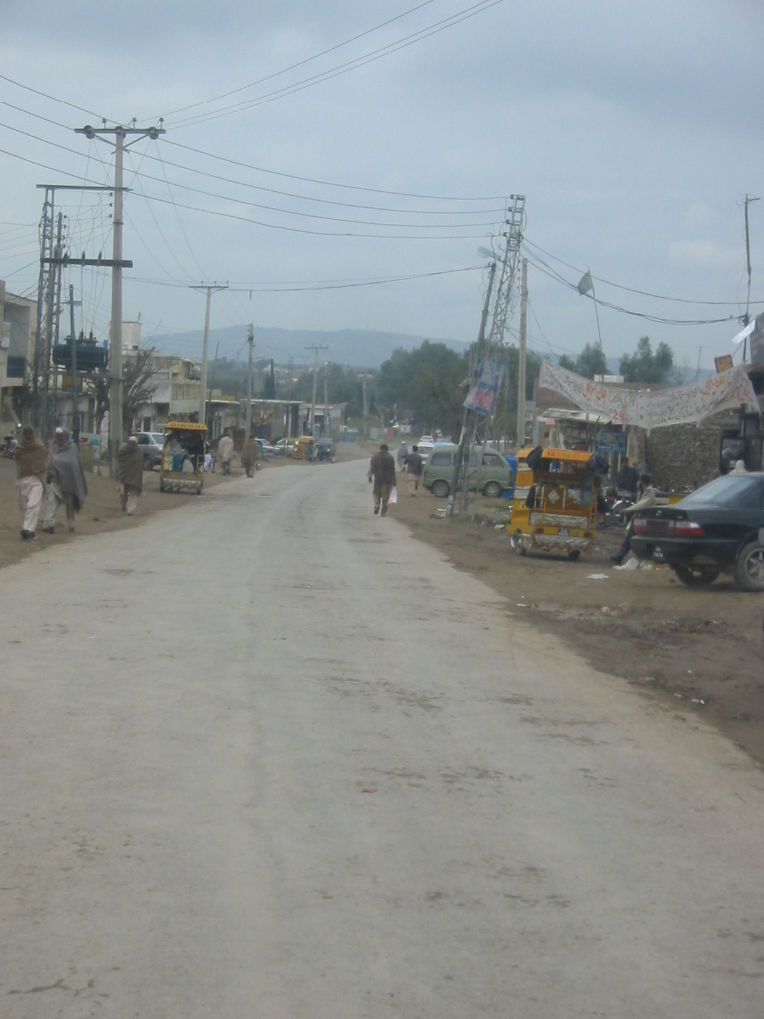
Exhibit 1:

5.1 Road Network

Fateh Jang is well-connected to other areas through a network of inter-city roads. The town is linked to Islamabad/Pindi, Attock and Kohat.

The mixture of fast and slow moving traffic causes delays, traffic jams, congestion, pollution and accidents. The overall condition of roads in the city is satisfactory. Main roads of the town are without footpaths and proper street lighting. The main bazars of Fateh Jang include Main Bazar, Sharqi Bazaar etc.

Table 8: Detail of Main Road Junctions in Fateh Jang:
Road Junctions | Converging Roads
Main Fateh Jang Chowk | Attock Road, Rawalpindi Road, Khor Road, Tehsil Road, Kohat Road
Main Bazaar Chowk | Main Bazzar, Tehsil Road, Eid Gah Road
Sardar Karam Khan Chowk | Sardar Karam Khan Road, Chassan Waki Dheri Road, Khor Road

Existing Condition of TMA Roads

The condition of roads in Fateh Jang is satisfactory. Most of the roads are in good condition and need minor repairs. Drainage is also satisfactory since topography has slopes that have steep gradients. Most small streets have P.C.C surface. Due to non-existence of metalled / paved shoulders and footpaths, some shopkeepers have encroached on the shoulders of the roads in busy areas. The existing length, road width, right of way, and existing condition of all metalled TMA roads is given as under.

Table 9: Major TMA Roads

S.# | Name of Road | Length | Av. ROW | Av. Metalled Width | Kind of Surface | Existing Condition
S.# | Name of Road | Km | Ft | Ft | Kind of Surface | Existing Condition
1 | Stadium Road | 0.7 | 20 | 15 | TST | Road is badly damaged with a lot of potholes.
2 | Bilal Masjid Road | 0.6 | 20 | 12 | TST | Road is badly damaged with a lot of potholes.
3 | Railway Station Road | 1.0 | 20 | 12 | TST | Good
4 | Old Tehsil Road | 0.8 | 24 | 12 | TST | Road is damaged with a lot of potholes
5 | Masjid Al-Murtaza Road | 0.7 | 20 | 12 | TST | Road is damaged with a lot of potholes
6 | Chassan Wali Dheri Road | 1.0 | 30 | 15 | TST | Road is badly damaged with a lot of potholes and cracks.
7 | Karam Khan Road | 0.6 | 30 | 12 | TST | Fair
8 | Mohalla Baba Wali Ahmad Road | 1.0 | 20 | 10 | TST | Road is badly damaged with a lot of potholes
9 | New Tehsil Road | 0.3 | 20 | 12 | TST | Road is badly damaged with a lot of potholes
10 | Post Office Road | 0.4 | 20 | 10 | TST | Fair condition with few potholes
11 | Khor Road | 1.5 | 80 | 12 | TST | Fair condition with few potholes

Needs

The Town is expanding due to normal growth and urbanization and traffic intensity on all roads has increased manifold. The under-mentioned two main roads are subjected to heavy traffic load due to increasing commercial and business activities. The areas served and important location / installation on these roads are summarized as under:-

Proposed Roads Projects

Following are the proposed projects for improvement of roads network and traffic system in Fateh Jang. Some roads have been taken up by district govt such as railway station road and Tehsil road in front of TMA office.

Table 10: The proposed road for reconstruction:

Reconstruction of Road
Road Name | Approx. Length | Rationale | Beneficiaries
OHR – Slaughter House -Rawalpindi Road | 1.5 km | This road would provides access to Rawalpindi road for residents. Part of the proposed road is kacha. | Residents of the south part of town would use this road for an access to Rawalpindi saving them time and resources.

Existing Streetlight System

There is proper streetlight system in Fateh Jang Town and lights are fitted on WAPDA poles with brackets. According to PMS, PMDFC data most of the town is served with street lights. There are 1162 street lights in town e.g 213 in UC-34 and 949 in UC-34. Only 9 % of the street lights are not working which is a good indication of the service provision and proper O & M. Mohalla wise Street light PMS, PMDFC data with it working status is shown in Annex A.

5.2 Water Supply

Under PMSIP a water supply improvement scheme is being initiated by PMDFC and TMA. Following information about water supply has been taken from Draft Feasibility Report prepared by the consultant.

Topography

The topography of the town is undulating with an elevation difference of 80 to 90 ft. the sub soil consists of red cohesive clay mixed with sand stone without any aquifer. The permeability is very low. Mostly rocks have vertical formation.

Sub Soil Water Conditions

The sub soil water depth varies from 35 to 90 ft below ground level and is directly linked up with rain fall frequency. In some portion of the town it is brackish where as in other areas, TDS value is within permissible limits. Installation of hand pumps is not possible.

Rationales for the Improvement/ Extension Of Water Supply System

Existing Water Supply System

The soil permeability is low hence limited quantity of underground water can be drawn. Indigenous hand pumps, ejector (motorized) pumps and open wells exist in the town. In summer, water vending is common. Water is sold through tractor tankers, donkey carts, motorcycle rickshaws etc.

The present sources of water

Source No. I (Open wells in the town)

In 1968-69, the first water supply system for the town was constructed. It consisted of four open wells located in the south of the town near TMA (municipality) office. The wells are located at a distance of about 500 feet from each other. The water from these wells was pumped (through turbines) to an elevated tank of 20,000 gallons, from where it was supplied to the households. This system is still in use except the elevated tank which has been abandoned, after its use for 15-20 years. At present the water from these open wells is directly pumped (from one well at a time) to the households. In the absence of rains, particularly in summer, there is a little water in these wells which is emptied within two hours or so. The turbine pumps are operated alternatively from 06:00 to 12:00 hrs and 14:00 to 16:00 hrs depending on the availability of water in the wells.

Source No.II (Presently abandoned)

In 1982, Bagwan water supply scheme was handed over to municipality by the PHED. This scheme was based on spring water located in the north of the town. The water was pumped to the town from this spring through 8 inches dia AC pipe of 11 kms length. In year 2002, the water source was taken over by Pakistan Atomic Energy Commission. Consequently this scheme has been abandoned by the TMA.

Source No.III (Open wells at Bank of Shah Pur Dam)

During 1994-98, open wells (4 nos.) were constructed on the bank of Shahpur Dam in the North East of the town near Nandna Nullah. This scheme is still functioning but the quality of water has been deteriorated due to non-functioning of percolation galleries connected with the open wells. At present water from the Dam is directly pumped to the city without any treatment. In rainy season the Dam water becomes turbid, and the same turbid water is supplied to the households.. The water is pumped to the 30,000 gallons ground tank located in the middle of the town through 10 inches dia and 21,900 feet long pipeline. Connections have been provided to influential consumers from the pumping main.

The water from 30,000 gallons ground tank is pumped to 100,000 gallons elevated tank (40 feet high slab level) located in the same compound, and to 50,000 gallons elevated tank (40 feet high base slab) through 6 inches dia pumping line having a length of 3,500 feet. The water is distributed to the households from these elevated tanks and also by direct pumping from 30,000 gallons ground tank. Almost all the distribution network (3 to 8 inches dia) material is PVC except few links of G.I and AC pipes. The technical details of the intermediate pumping station (IPS) located at 30,000 gallons ground tank are given as under.

Table 11: Technical Details of Intermediate Pumping Station

Description | Pump type | Motor (HP) | Motor (rpm) | Estimated Pump Capacity when pumped to 100,000 gallons elevated tank (gph) | Estimated Pump Capacity when pumped to 50,000 gallons elevated tank (gph)
Pump No. 1 | Centrifugal | 20 | 2940 | 12,500 | 7,000
Pump No. 2 | Centrifugal | 15 | 2940 | 10,000

Service delivery level

Water is supplied to the households through 100,000 gallons elevated tank from 06:00 to 17:00 hrs and through 50,000 gallons elevated tank from 06:30 to 15:00 hrs. There are about 100 valves installed on the distribution system which are operated on alternate days and households get water for about 90 minutes or so. The households store water at the ground level and tanks constructed at the roof top. It is common practice to construct concrete or fiberglass tank at roof top.

At present water is not provided to “Mohallah Chasari Wali Dheri” located in the south –west of the town and part of “Mohallah Chishti Abad” located in the north-west of town. Although distribution system has been installed in these areas but water is not supplied due to inadequate quantity available to TMA (see key plan).

Overhead Storage

Table 12 : Details Of Existing Water Storage Tanks

Tank Location | Storage Capacity (gallons) | Slab height (feet) | Comments
Ground tank at main waterworks in Town | 30,000 | - | In use
Elevated tank at main waterworks in Town | 100,000 | 40 | In use
Elevated tank near old Civil Hospital | 50,000 | 40 | In use
Elevated tank near Masjid Loharan | 20,000 | 40 | Not in use
Total | 200,000

Consumer Data

There are 2900 domestic and 70 commercial connections. Almost all the commercial consumers pay monthly water tariff. Door to door tariff collection is done by the TMA staff. However, the users can also pay tariff at the TMA office. The wastewater generated from the houses is discharged into open/ covered drains. Natural gradient helps the wastewater to flow in the drains hence sewerage/ drainage is not a priority for the TMA.

O & M Expenditure and Revenue Collection

Table 13: Water Tariff Collection and Expenditure

Expenditure  (year 2004-05) | Amount (Rs) | Income  (year 2004-05) | Amount (Rs)
Establishment Charges | 14,03,000 | Budgeted Revenue | 1,717,200
Electricity Charges | 18,00,000 | Actually Received | 6,81,665
Repair and maintenance | 8,00,000 | % Recovery | 40 %
Total | 40,03,000

Ratio of revenue recovery to O & M charges = 17 %
Deficit being met by TMA out of other income sources = 3.32 million
The main reason for low recovery is the shortage of water and supply of raw water containing smell and colour which is not acceptable to the people and hence they are reluctant to pay for water.

Needs

Presently there are two water sources for the town. i) Shahpur Dam and ii) 4 open wells near TMA office. The major quantity of water supplied to the town is from the Shahpur Dam. The water is supplied without any treatment and is turbid hence the residents do not prefer it for drinking purpose. The water from 4 open wells is available in a little quantity and is supplied to only one part of the town. The water is supplied on alternate days. Some residents have installed hand/motorized pumps to draw ground water where it is available. In dry season the water table is lowered and the quantity of water from ground sources including municipal open wells (4 Nos) is reduced. Consequently, the residents buy water from vendors, which bring water from private open well installed on the periphery of the town. Hence potable and safe water is the dire need of the town.

Problems/ Issues

The estimated water production from two water sources is 480,000 gallons. Considering 34,012 persons (current population year 2005), the water supplied would be about 14 gallons per capita per day whereas the government of Punjab design criteria suggests 40 gallons per capita per day. Due to inadequate quantity of water available, the TMA supply water to the households on alternate days. Further, the TMA does not supply water at all to a part of the town inspite of the existence of distribution network in this area.

In conclusion Fatehjang is facing two issues, i) inadequate quantity of water supplied to the households and ii) poor quality of water supplied.

Improvement Required With Justification

Improvement in quantity of water

Since Shahpur Dam is the only reliable source of water for the town, therefore, it is proposed to install 18 inches dia pipe line (parallel to existing 10 inches dia pipeline). These pumping mains will meet the water needs of the town for the year 2025. Additional water storage has been suggested along with pumping machinery which will meet the requirements of the town for the year 2015. A few links and distribution pipes have been proposed for the equitable distribution of water.

Improvement in quality of water

Water treatment plant (slow sand filters) has been proposed at the Shahpur Dam. The treatment will ensure supply of potable water to the town.
The town’s water requirements are given as under.

The Sub-Project

Description

To improve the water supply situation in the town, following improvements are required:

Improvement in Water Source

This would include, i) water treatment plant at Shahpur Dam and pumping machinery, ii) treated water ground storage tank at treatment plant, iii) 18 inches dia water pipeline of 21,900 feet length and iv) ground storage tank at main waterworks located in the town.

Improvement in Distribution System

The existing distribution system is generally in good condition. The improvement in distribution system would include, i) pumping main from main water works to 50,000 gallons elevated tank located near old Civil Hospital, ii) pumping main from main water works to 20,000 gallons elevated tank near Masjid Loharan and iii) distribution system in lanes.

Operation and Maintenance Implications

There are 21 staff members for the O&M of the existing water supply system. It is expected that the same staff will be adequate for the O&M of the improved system. However, the O&M staff needs training on the O&M of the system particularly the treatment plant. The O & M cost and the tariff required to be levied is given as under: -

No. of house holds in year 2015 = 8058
Assuming connectivity of 90% (No other source available)
No. of connections = 7252 Nos.
Assumed tariff = Rs. 100 / month
Total revenue / annum with 10% delinquency rate = 7.83 million
O & M charges in year 2015 = 14.70 million
Deficit = 6.87 million

A flat rate of Rs. 100 / connection is recommended for the raised tariff. However it has to be assured if TMA Fateh jang is capable to meet this deficit from other sources of income. Presently TMA Fateh jang has given the undertaking that they are capable to meet this deficit for bigger interest of the residents of the town. During preparation of feasibility report this aspect has to be given a special attention.

5.3 Sewerage

Presently, there is no sewerage system in Fateh Jang and the whole town is connected with open rains of Type I & II. Natural slopes of the town provide with good disposal. Old part of town is located on elevated areas whereas, new areas developed lie on flatter surfaces.

PHED has recently surveyed the area for a possible sewerage plan. According to TMA staff and stakeholders old part of town that lies on higher slopes has rocks at its foundation and sewerage won’t be feasible. In areas such as, Chanse Wali Dheri, Attock Road, Stadium Road, Pindi Road, Tehsil Road, Kamran Khan Mohalla etc sewerage network can be laid. In addition PMSIP water supply scheme would add to sewerage effluents.

Table 14: Sub-Project Proposal

Proposed  Sub-Project | Rationale | Beneficiaries
Development of Sewerage Network in Fateh Jang | Presently, there is no sewerage system in Fateh Jang and the whole town is connected with open rains of Type I & II.. Areas surrounding old part of town can be connected with sewerage network. PMSIP water supply scheme for Fateh Jang would increase amount of sewage and would need a sewerage network, otherwise, pools of sewage would be developed resulting in spreading of diseases. | Whole town of Fateh Jang.

5.5 Solid Waste Management

General

The existing solid waste management system of Fateh Jang is being managed by the Tehsil Municipal Administration (TMA). The existing solid waste collection in general is divided into primary and secondary collection system. However, there is no proper solid waste disposal system in the Town.

Fateh Jang is relatively clean town. There is a nice system of skips placed covering most of town for secondary collection. Waste is disposed of, in open dumps along

Waste Generation and Collection Efficiency

The present population of Fatehjang is 38,000, by taking generation rate of 0.4 kg/capita/day, generated solid waste comes out to be 15.2 tons per day. (PMS, PMDFC)

Total daily lifting capacity of TMA vehicles used for the collection of solid waste is 10.46 tons per day. There are two tractor trolleys used for solid waste of carrying capacity 3.5 tons and 2.0 tons respectively. Both take 2 trips to the dumping sites each day. Collection efficiency of the municipal vehicles worked out to be 69 % (PMS, PMDFC).

Solid Waste Management System

The existing solid waste management system of Fateh Jang comprises of on site storage, collection, transfer and disposal. Brief description of each activity is discussed as follows.

Solid Waste Collection

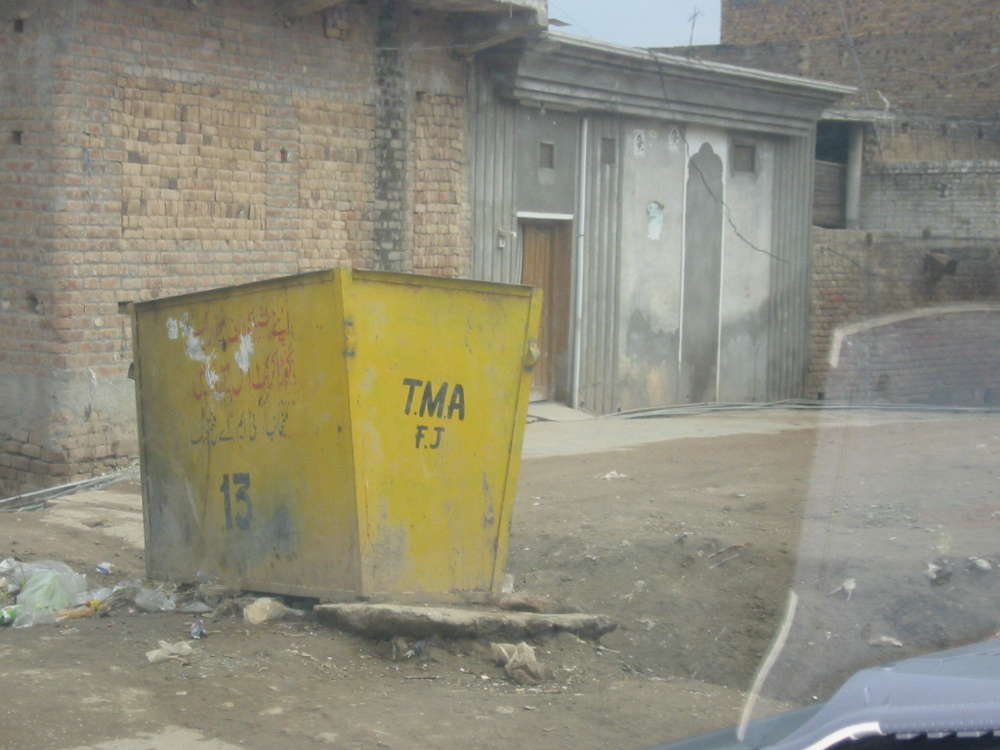
Existing solid waste collection system comprises of the following primary and secondary collection;
Exhibit:

Primary Collection

Primary collection is being performed by sanitary workers. The workers carry out sweeping of streets and roads and collect the solid waste from small heaps with the help of wheel barrows, brooms etc. and store at permanent and temporary collection points. There are 49 sanitary workers deputed at various locations and roads all around the town. Most of the town is covered except newly developing areas or areas with less development.

In addition to solid waste, sludge and grit is also removed from drains by sanitary sweepers and are placed along drains in the shape of small heaps which then is collected by wheel barrows from narrow streets and directly by tractor trolleys from wide street areas.

Secondary Collection System
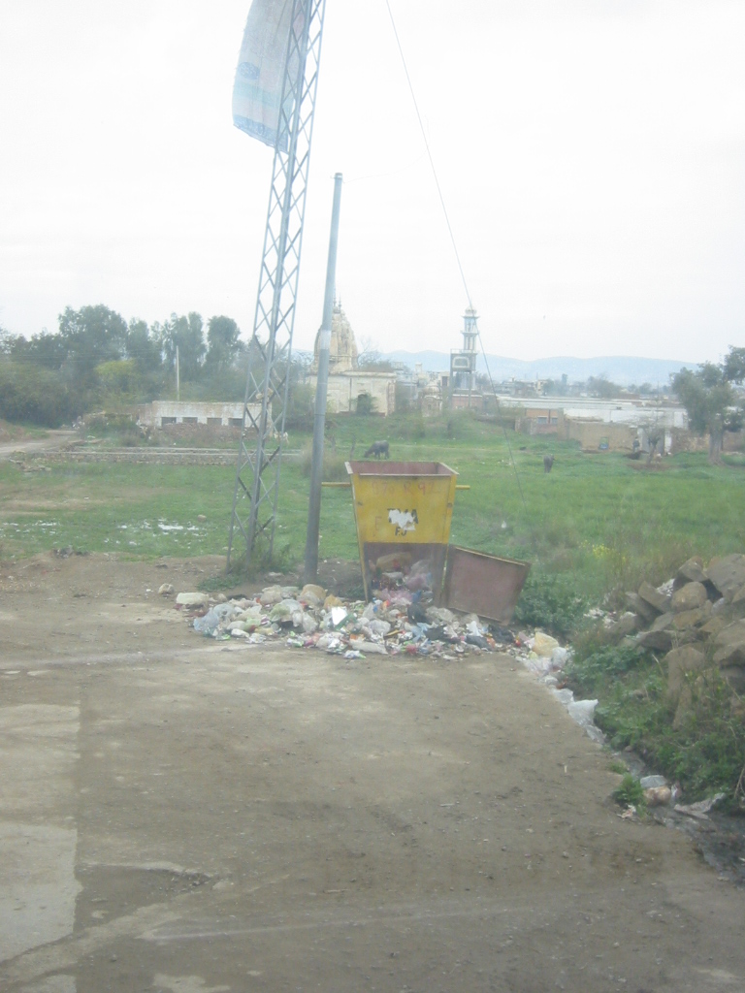
Exhibit:
After primary collection, tractor trolleys pick the waste from the primary collection points and dump it to open spaces. In Fateh Jang Town, there are existing collection points as mentioned in Annex D. Some primary collected waste remains unattended due to shortage of equipment and manpower.

Collection and Management of Special Wastes

Hospital, slaughter house, industrial, demolition and construction waste along with dead animals may be termed as special wastes. Arrangements to deal with these types of wastes in Fateh Jang are as under:

Hospital Wastes

A civil hospital, few private hospitals and a large number of private clinics are located in the town. Private hospitals also have indoor patients treatment arrangement. The different types of refuse are primarily collected from various hospitals by the hospital sweepers and are dropped into the municipal solid waste collection containers without segregating hazardous waste and are ultimately disposed off with municipal solid waste.

Slaughter House Wastes

In Fateh Jang Town, a slaughter house is located at Slaughter house road Road and is operated by TMA. Slaughter house waste is disposed of with municipal waste..

Solid Waste Disposal

Solid waste is being disposed of long roads that lead out of town and thrown into depressions. There is no proper land owned by TMA for scientifically disposing of solid wastes.

Table 15: Demand for Service
Year | 2006 | 2011 | 2016
Generation (tons) | 15.20 | 17.13 | 20.77

With existing resources Fateh Jang is able to dispose of 50 % of the generated solid waste. In 5-10 years a lot more equipment and human resources would be needed. Human resources would not be available in this field. Therefore, a comprehensive plan should be drafted and implemented including a sanitary landfill site, requisite equipment and HRM planning.

Table 16: Sub-Project Proposal

Proposed Sub-Project | Rationale | Beneficiaries
Improvement of SWM in Fateh Jang and procurement of land for landfill site | Management and operational improvements, procurement of machinery and landfill site are needed to improve SWM in Fateh Jang.  Present disposal sites is polluting the environment. | Whole town of Fateh Jang.

5.6 Fire Fighting

There is no fire fighting arrangements in Fateh Jang. Town is not a large one and is not an industrial town. According to TMA staff there have-not had been many fire incidences for last few years and they get a fire engine from OGDC. But as fire fighting is an essential municipal service and an efficient fire fighting arrangement is must for Fateh Jang.

Table 17: Proposal

Proposal | Rationale | Beneficiaries
Establishing Fire Fighting arrangement in Fateh Jang | TMA Fateh Jang doesn’t have fire fighting arrangement for its citizens. As fire fighting is an essential municipal service, establishment of fire fighting station , procurement of fire engine and other equipment and training of staff for fire fighting service is essential. | Population living in Fateh Jang.

5.7 Parks

According to the planning standards adopted by the government of the Punjab there shall be at least 5 -7 % of the area under parks.

TMA has large piece of land next to its premises and plans to develop a park. It ideally suited for the purpose as it is not far from centre of the town.

Table 18: Proposal for Parks

Proposal of park | Rationale | Beneficiaries
Park near TMA office | There is no park in Fateh Jang A park would greatly enhance living standards of population living the town. A large land is available with TMA near its office that can be used to develop a modern park with requisite facilities. | Population living in Fateh Jang.

5.8 Slaughter House
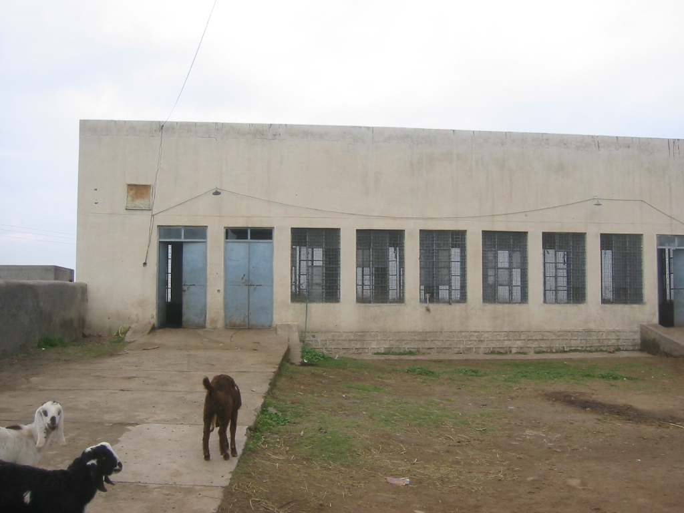
Exhibit:

Existing Slaughter House

Location

The location of the existing slaughter house is located away from population on east side of town. It is located a 1.25 km from TMA office. It takes of from a main road of width 10 feet which is in good condition. Therefore, even during raining season animals can easily be brought here for slaughtering. The approach road is 200 feet long and is in fair condition. There are no traffic problems around slaughter house. The only buildings near slaughter house are resident quarters of sanitary staff and a mosque. There is only one slaughtering hall that is also used for skinning hall. There is an covered veranda on east side of slaughter house that is used to slaughter big animals. Covered area of the two structures is 1600 square feet. Total area of premises is 2.1 kanals. 10-12 large and 50-60 small animals are brought each day for slaughtering. Revenue collection is auctioned out. Budgeted estimate of year 2006-7 is Rs. 150,000.
Existing Capacity and Requirements
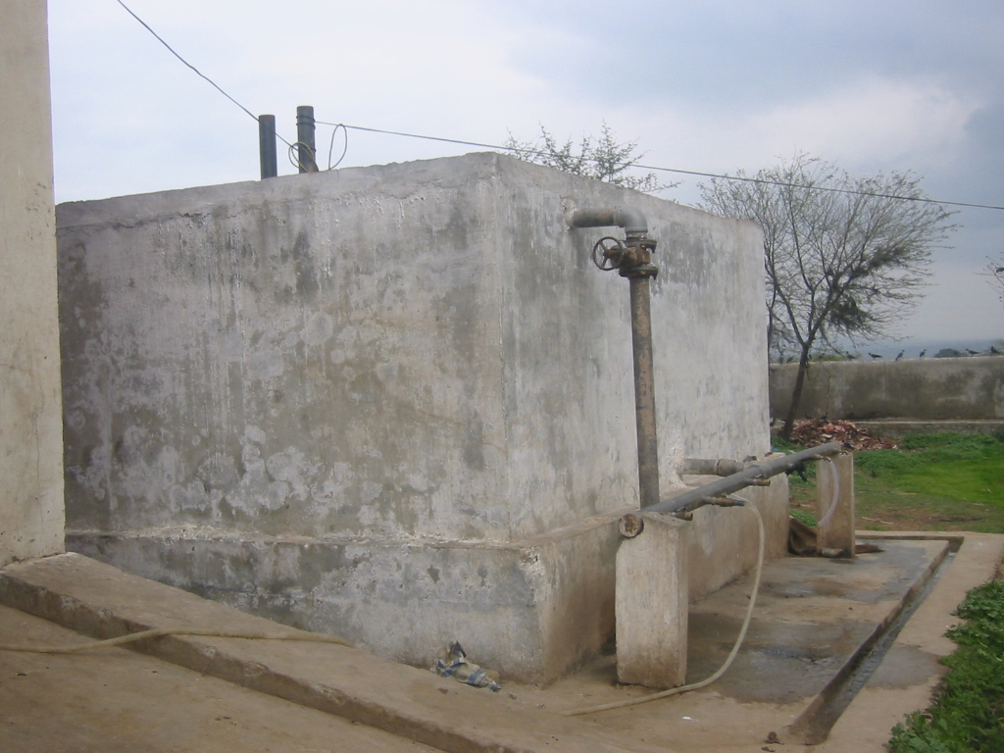
Exhibit:
At present most of the slaughtering is done illegally at different locations of Fateh Jang city due to non availability of proper facilities at the existing slaughter house. The existing capacity of both the facilities is in adequate to meet present as well as future demands.

Water Supply System
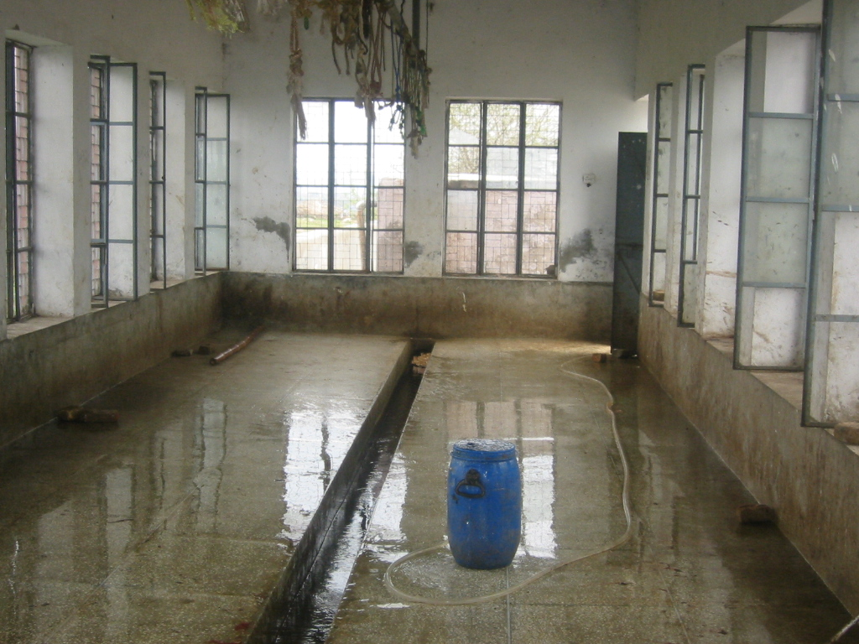
Exhibit:

The existing water supply from TMA public water supply system consists of 3” dia. GI pipe. Water is supplied 2-3 times each day and stored in a on-ground storage tank of 5000 gallon capacity. From water tank plastic pipes are used to transmit water for washing. According to TMA staff there is no water shortage in the premises.

Drainage and Disposal System

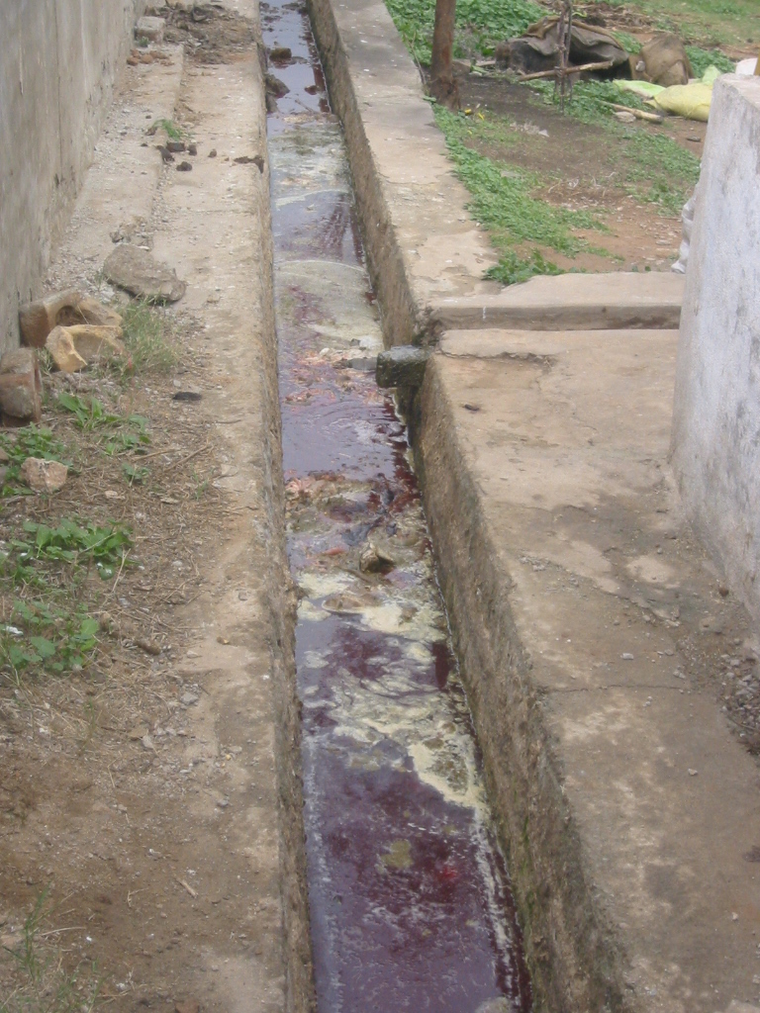
The present effluent disposal in the slaughter house has not been connected to the city’s sewerage system and is being discharged into open fields without any treatment causing very unhygienic environment in the surrounding area and possible contamination of the ground water.
Exhibit:

Solid Waste System

There is no system for the disposal of solid waste. Most of time the solid waste heap stays there and become breeding place for mosquitoes and flies. It is thrown at back of the slaughter house in open land. It is disposed of by TMA SWM team after 2-3 days.

Existing Man Power of Slaughter House

There is veterinary doctor who receives honorarium of Rs.800.00 per month which is an extremely low compensation. There is one sanitary worker and one chowkidar (guard) under TMA’s sanitation establishment who are deputed to look after the slaughter house.

Observations on Existing System of Slaughter House

Slaughter is presently away from population therefore, there are no social issues involved. City is expanding towards east side therefore, they will be living near the slaughter house resulting in social and environmental problems

Solid waste is un hygienically disposed of in open land causing soil and water contamination. Sold wastes should be picked up each day to avoid small and breeding of insects that may cause diseases.

Present slaughter house can serve TMA for at least 5-7 years.

Chapter VI

WORKSHOP ON PRIORITIZATION OF INFRASTRUCTURE SUB-PROJECTS

Projects identified were based on surveys, analysis and ‘technical judgment’. The projects identified needed validation and prioritization by the elected representatives of the people through consultations.

The following methodology was adopted for the prioritization process.

6.1 Pre-Workshop Consultations

PMDFC held meeting with Tehsil Nazim to discuss and finalize the workshop methodology. The purpose was to develop a common understanding and build consensus about the workshop methodology and the proposed projects. The Tehsil Nazim was requested to invite the participants for workshop and make available suitable venue for it.

PMDFC briefed how the workshop would proceed, including details about formation of groups, inter-sector prioritization (i.e. roads vs water supply vs sewerage etc.), followed by intra-sector prioritization, e.g. in case of roads sector, individual road projects for the whole town were prioritized.

6.2 Workshop Proceedings

General
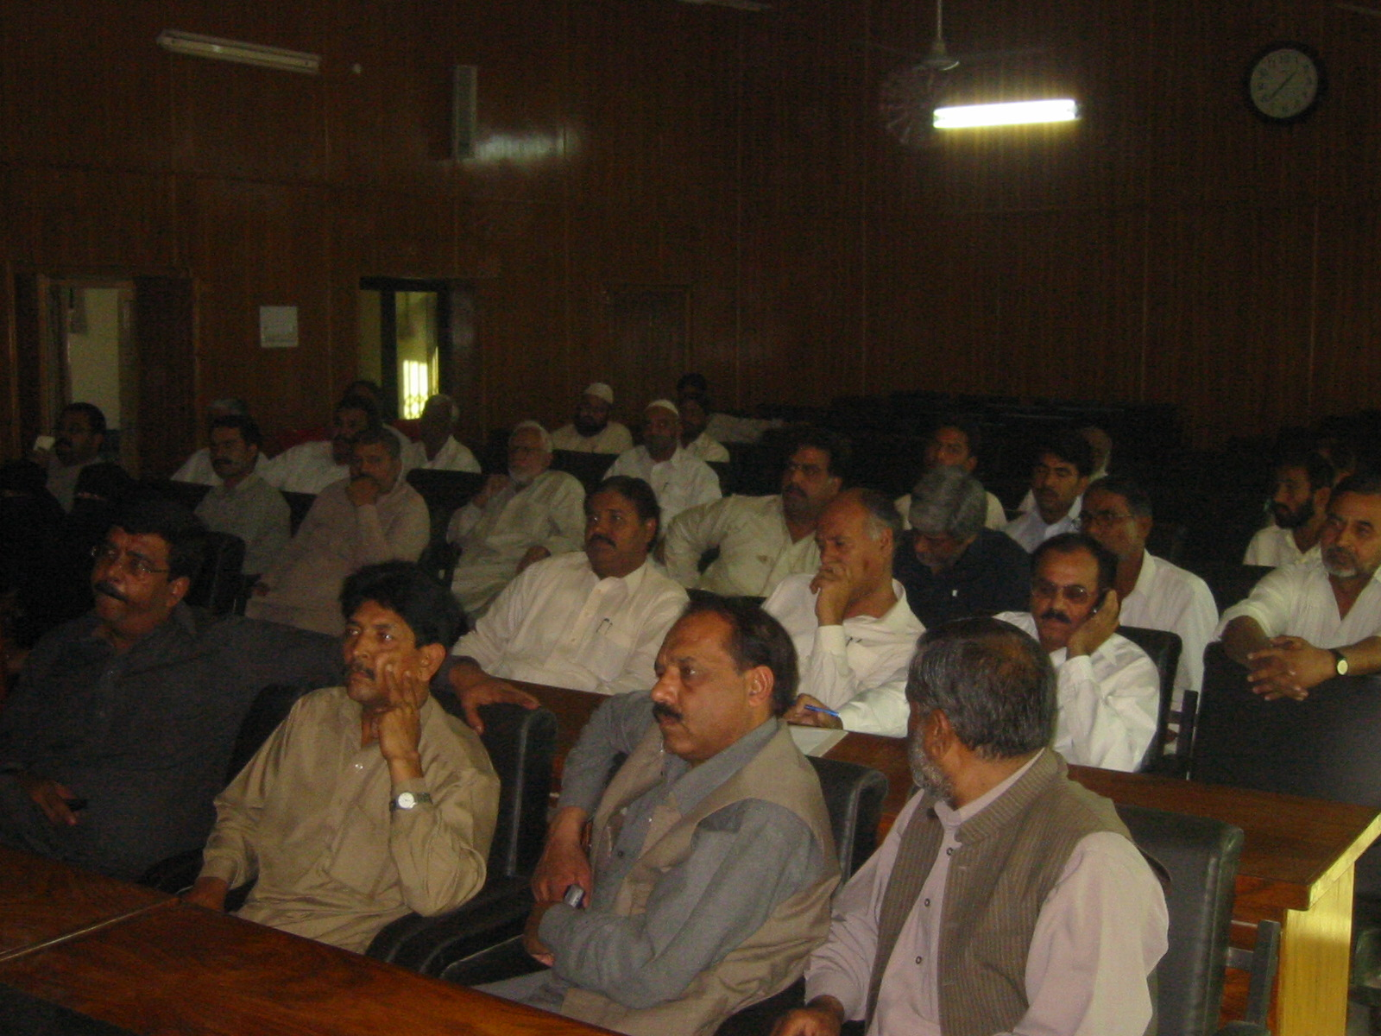
Exhibit:
The work shop was held on 6th November, 2007, in TMA complex, Fateh Jang. It commenced at 12:00 p.m and was concluded at around 2:30 p.m.

Workshop Participants

The number of participants was 35. The stake holders were mainly the representatives of the Tehsil Council and Union naib nazims, from 2 urban UCs of TMA Fateh Jang.

List of participants is appended at the end of this report.

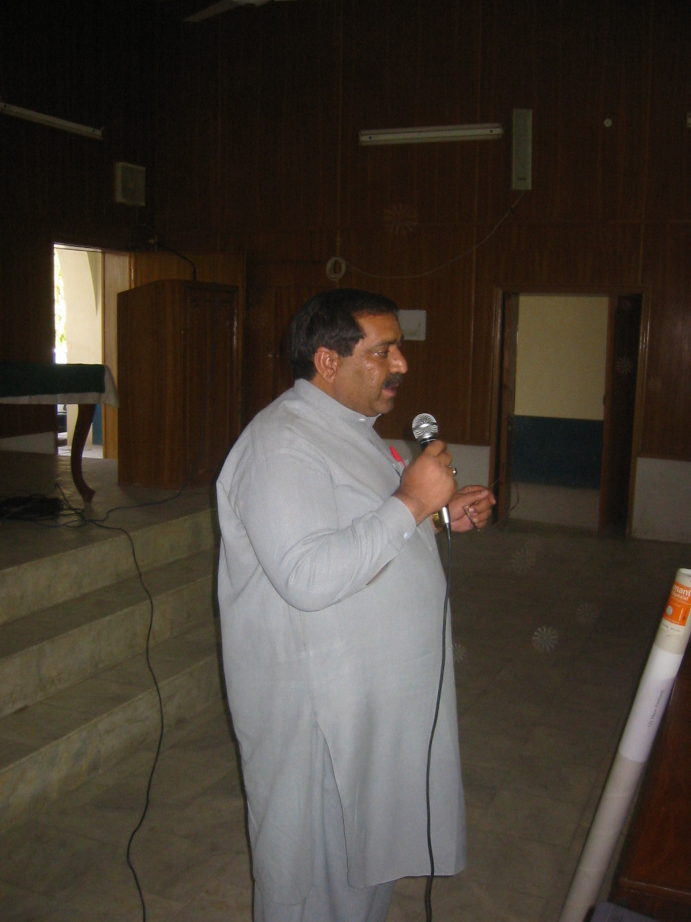
The Session
Exhibit:

The workshop was formally started with a presentation was given by PMDFC on, the existing situation of the town and proposed list of sub projects. During the presentation, the participants took a keen interest, and asked a number of questions about the working of, and already projects under taken by PMDFC. They further updated the information about the existing situation, e.g. the stakeholders had serious reservations about the fire fighting system, as it was considered inefficient.

Group Formation

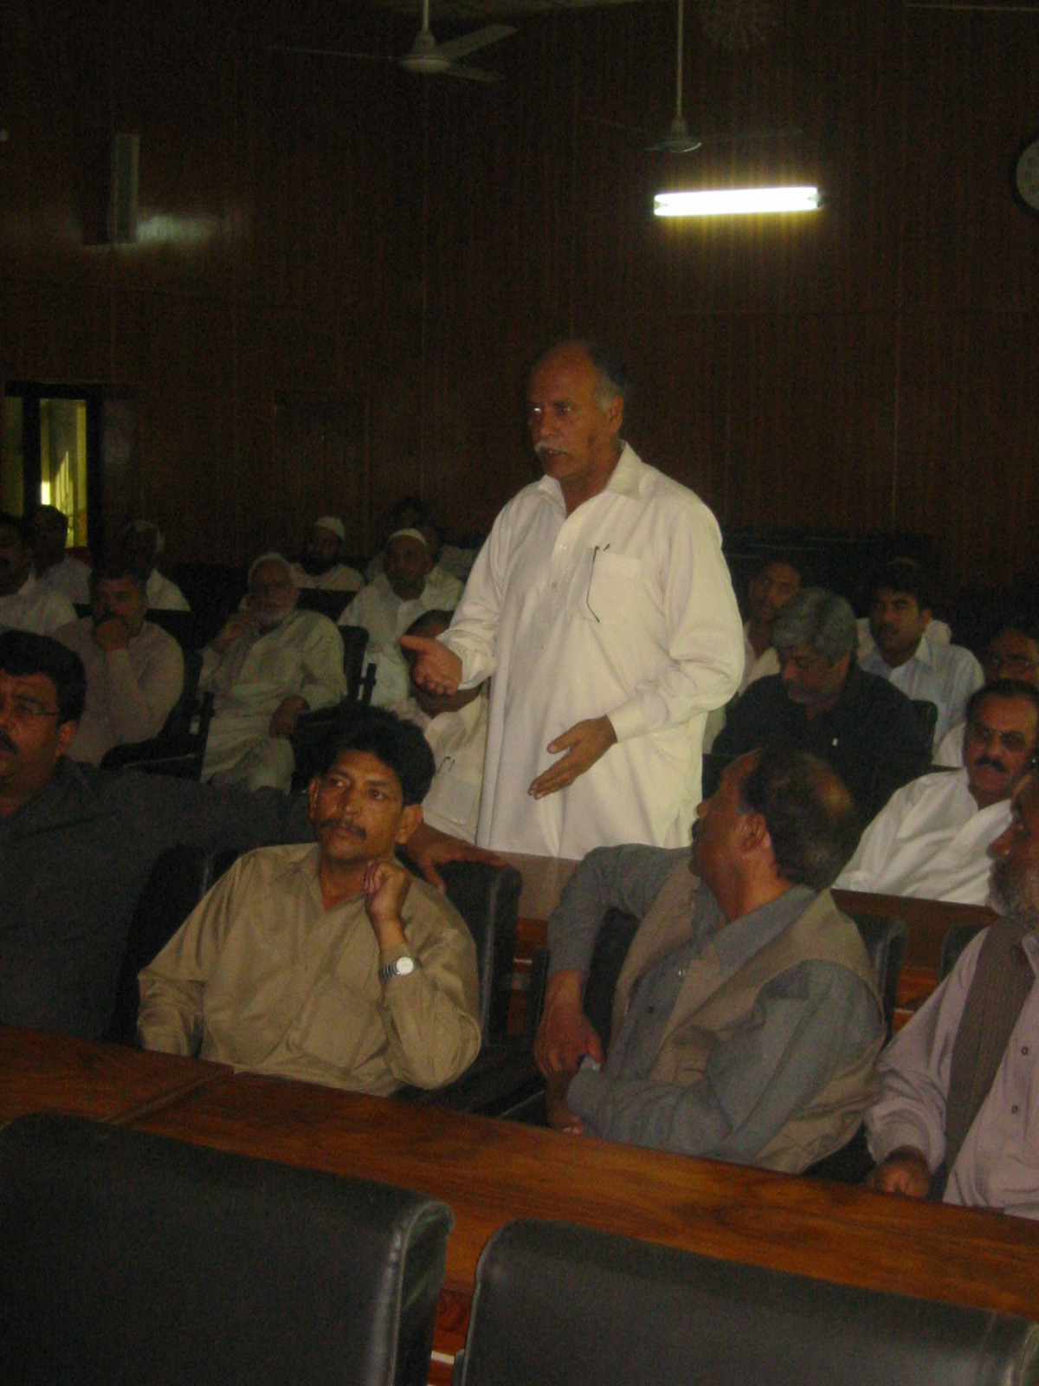
The participants were divided into 3 groups at random, but it was ensured that people form same UC may not be included in the same group. Each group comprised of 4-5 persons.
Exhibit:

In the first round, inter-sector prioritization was done. Each group was given a list of sectors i.e. roads, water supply, sewerage etc. They were first to label their priority before each sector e.g. if they thought drains was the most important problem of the town they were to assign 1 before drains, etc.

The results of the Inter sector prioritization were entered into a ‘priority matrix’. In this matrix, the group-wise sector priorities were entered as assigned by the group members. Based on the frequency of responses, the inter-sector prioritization was finalized.

In the second round, group members were asked to prioritize intra-sector projects. Thus in case of roads, name of individual roads identified were written Intra sector prioritization matrix. The participants suggested some new projects to be included, e.g. street lights, which had not been identified by the PMDFC. The priority-wise projects were then entered in intra-sector priority matrix, and sub-projects finalized on the basis of frequency of responses.

Thus a prioritized list of projects was developed for TMA Fateh Jang, as shown below:

6.3 Prioritized List of Sub-Projects

Table 19: Prioritized Projects- Fateh Jang

Sector | Sector Priority | Sub-Projects
Water Supply | 1 | PMSIP - sub-project
Sewerage | 2 | Development of sewerage network
Solid waste management | 3 | Improvement/Extension of SWM
Roads | 4 | Improvement of roads
Street light | 5 | Improvement/Extension of street lights
Fire fighting | 6 | Development of fire fighting system
Slaughter house | 7 | -
Park | 8 | -
Bus stand | 9 | -

The Planning process adopted rules out the selection of projects at random or biasness, rather it reflects the ground realities and is demand driven. If the projects are not need based, they are not sustainable for long period of time and become redundant without any benefit to the community or the user. Even if such projects survive, they benefit only a specific group of people. It is therefore important for Infrastructure projects to be need based and both beneficial to and acceptable to the community. To make it mandatory, the involvement of stakeholders was ensured at all stages of planning, including the process of prioritization of the development projects.

ANNEXES
Annex – A
Street Light Data
Table 20:
Fatehjang
Union Council | Mohalla | Streets | No. of St Lights | St Lights not Working
35 | Masjid Garan Wali | 13 | 48 | 5
35 | Masjid Bibi Anaran | 7 | 23
35 | New Bus Stand | 1 | 4 | 2
35 | Qazi Abdul Bari Wali | 7 | 34 | 2
35 | Mohalla Post Office | 3 | 6 | 0
35 | Rawalpindi Road | 1 | 11 | 1
35 | Masjid Mohalla Habib | 3 | 16 | 3
35 | Mohalla Wadi ban | 6 | 36 | 1
35 | New Abadi Pindi Rd | 5 | 14 | 4
35 | Mohalla Ichral | 7 | 21 | 0
35 | Main Rd Bazar | 1 | 28 | 3
35 | Masjid Loharan | 7 | 42 | 1
35 | Jamia Masjid | 4 | 22 | 3
35 | Amam Bargah | 6 | 23 | 1
35 | Paran Wali Masjid | 7 | 37 | 5
35 | Makhdoom Jahania | 3 | 6 | 1
35 | Sumballan | 4 | 30 | 7
35 | Masjid Chairman | 6 | 35 | 4
35 | Ustad Gama Wala | 6 | 27 | 3
35 | Masjid Ghulam Jilani | 10 | 28 | 3
35 | Masjid Molvi Khar | 13 | 102 | 9
35 | Karam Khan Rd | 10 | 52 | 7
34 | Mohalla Eid Gah | 7 | 57 | 5
34 | Masjid Mulla Bukhari | 8 | 47 | 6
34 | Anarkali Market | 2 | 16 | 3
34 | Masjid Bilal Road | 8 | 45 | 1
34 | Railway Station Rd | 14 | 40 | 2
34 | Attock Road | 9 | 64 | 2
34 | Makki Masjid | 3 | 50 | 6
34 | Peer Ahmad Shah | 3 | 34 | 3
34 | Chandni Chowk | 12 | 39 | 4
34 | Nooria Rizwia | 9 | 61 | 6
34 | Kohat Road | 1 | 26 | 3
34 | Malik Noor Zaman | 6 | 37 | 5
34 | Masjid Al-Murtaza | 28 | 1 | 0
34 | Chastia Abad | 2 | 0 | 0
34 | Chasa Wali Dhari | 25 | 0 | 0
34 | Habib Abad | 5 | 0 | 0
34 | Total | 272 | 1162 | 111

Annex – B

Table 21: Water Supply Data

Tube well no | Location of tube well | OHR | Served localities | Total Opr. Hrs | Total Supp. Hrs | Av. Supp hrs
1 | Committee bagh | Committee bagh | Mohalla lal jahanian, madina town | 297.00 | 153.30 | 4.95
2 | Committee bagh | Committee bagh | Mohalla lal jahanian, madina town | 297.00 | 153.30 | 4.95
3 | Old bus stand | - |  | 152.00 | 152.00 | 4.90
4 | Nathay shah | - |  | 157.30 | 157.30 | 5.07
5 | Near polie station near sadar | - |  | 61.00 | 61.00 | 1.97
6 | Katchi abadi | - |  | 153.00 | 153.00 | 4.94
7 | Multan road | - |  | 158.00 | 158.00 | 5.10
8 | Near tehsil office | - |  | 161.30 | 161.30 | 5.20
9 | Near DSP office | - |  | 153.30 | 153.30 | 4.95
 | Total |  |  | 1589.90 | 1302.50 | 42.02

Table 22:

Tube  Well # | Location | UC # | Date of establish/ Bore Date | Design Data |  |  |  | Pumping hours | Type | Deficiency/Repair required
 |  |  |  | Discharge, gallons | Head | HP | RPM |  |  | Condition
1. | Peoples Colony | 1 | 1977 | 8000 | 300 | 30 | 2900 | 15 | Submersible | OK | -
2. | Peoples Colony | 1 | 1999 | 8000 | 250 | 20 | 2900 | 15 | Submersible | OK
3. | Darul Islam Colony | 1 | 1976 | 6000 | 210 | 20 | 2900 | 20 | Vertical | Unsatisfactory, | New column pipe 64’ required
4. | Al-Janat Hospital | 1 | 2001 | 8000/hr | 300 | 30 | 2900 | 20 | Submersible | OK | Electric starter not working properly
5. | Mohalla Awan Sharif | 1 | 1992 | 10000 | 300 | 30 | 1400 | 15 | Vertical | OK
6. | Meharpura Sharqi | 1 | 1990 | 8000 | 300 | 30 | 2900 | 15 | Submersible | OK
7. | Meharpura Gharbi | 1 | 1975 | 8000 | 300 | 30 | 2900 | 15 | Submersible | OK
8. | Bahar Colony | 1 | 1997 | 8000 | 300 | 30 | 2900 | 16 | Submersible | OK
9. | Graveyard | 1 | 1999 | 8000 | 300 | 30 | 2900 |  | Submersible | OK | 5% leakage due to supply line
10. | Eidgah Tanky | 2 | 1975 | 8000 | 300 | 30 | 2900 |  | Submersible | Bad, giving sand | 4% due to valve fault
11. | R Block Nafees Chowk | 2 | 1975 | 8000 | 300 | 30 | 2900 |  | Submersible | Ok | 3% due to valve fault
12. | R Block School No. 3 | 2 | 1991 | 8000 | 300 | 30 | 2900 |  | Submersible | Ok | 3% due to connection pipe, valve etc.
13. | Water Works Tanky | 2 | 1990 | 8000 | 300 | 25 | 1450 |  | Submersible | Ok | 4% due to valves etc.
14. | Water Works Sabzi Mandi | 2 | 1999 | 8000 | 300 | 30 | 2900 |  | Submersible | Ok | -
15. | Cattle Market No. 15 | 2 | 2001 | 6000 | 220 | 20 | 2900 |  | Turbine | OK | -
16. | Office TMA | 2 | 1971 | 6000 | 300 | 30 | 2900 |  | Submersible | Ok | -
17. | Block D Tanky | 2 | 1996 | 8000 | 300 | 30 | 2900 |  | Submersible | Ok but less water | 5% due to valve, motor blown out
18. | Block K | 2 | 2000 | 8000 | 300 | 30 | 2900 |  | Submersible | Ok | 6% due to valve
19. | Jinnah Bagh | 2 | 1982 | 6000 | 300 | 20 | 1450 |  | Turbine | Unsatisfactory | 3% due to valve
20. | Dhoke Fateh Tanki | 3 | 1989 | 6000 | 200 | 25 | 1450 | 19 | Vertical | gives gravel, new bore required, | Sluice valve & pumping machinery replacement, pump house repair
21. | Dhoke Fateh Karbala | 3 | 1982 | 8000 | 300 | 30 | 1450 | 19 | Vertical | Not OK new bore required | Valves, machinery repairs required,
22. | Choti East | 3 | 2005 | 8000 | 300 | 30 | 1450 | 19 | Submersible | Ok | Electric Fan required
23. | Masjid Bilal | 3 | 2001
24.
25. | Shah Faisalabad | 3 | 1991 | 6000 | 220 | 20 | 2900 |  | Submersible | OK | Valves & Pump house repair /replacement
26. | Farooq e Azam Colony |  | 2006 | 8000 | 300 | 30 | 2900 |  | Submersible | Ok

Table 23: The technical details for the Shahpur Dam.

Description | Dia of open well (ft) | Pump Type | Motor (hp) | Motor (rpm) | Estimated Pump Capacity (gph) | Working hours | Daily water production (gallons) | Comments
Well No.1 | 15 | Turbine | 60 | 1470 | 15,000 | 16 | 320000* | Pumped to 30,000 gallons ground tank
Well No.2 | 15 | Turbine | 40 | 2900 | 10000 | 16 | 320000* | Out of order
Well No.3 | 15 | Turbine | 30 | 2900 | 5000 | 16 | 320000*
Well No.4 | 15 | Turbine | 30 | 2900 | 5000 | 16 | 320000* | Out of order

Table 24: Average Hours of Water Supplied to Households per Day
For the Month of September 07
TMA Fateh Jang
Main Valve | Sub-Valve |  | Total hours water supplied to HH during last month | Avg. hours water supplied to HH during last month
Main Valve | Valve No. | Name / served Localities | Total hours water supplied to HH during last month | Avg. hours water supplied to HH during last month
Gharbi Tanki - Valve No. 1 | 1 | Khoor Road | 15.00 | 0.48
Gharbi Tanki - Valve No. 1 | 2 | Street Karam Elahi Thekaidar | 15.00 | 0.48
Gharbi Tanki - Valve No. 1 | 3 | Street ID-Card Office | 15.00 | 0.48
Gharbi Tanki - Valve No. 1 | 4 | Street Head Master Noor Zaman | 15.00 | 0.48
Gharbi Tanki - Valve No. 1 | 5 | Street Ameer Aalam | 10.00 | 0.32
Gharbi Tanki - Valve No. 1 | 6 | Street Makki Mosque | 10.00 | 0.32
Gharbi Tanki - Valve No. 1 | 7 | Chandani Chowk | 10.00 | 0.32
Gharbi Tanki - Valve No. 1 | 8 | Street Khan Bahadur | 15.00 | 0.48
Gharbi Tanki - Valve No. 1 | 9 | Street doctor Sarwar | 7.30 | 0.24
Gharbi Tanki - Valve No. 1 | 10 | Ziarat Peer Ahmad Shah | 15.00 | 0.48
Gharbi Tanki - Valve No. 1 | 11 | Street Masjid Loharan | 15.00 | 0.48
Gharbi Tanki - Valve No. 1 | 12 | Street Jamia mosque | 15.00 | 0.48
Gharbi Tanki - Valve No. 1 | 13 | Andar Kot | 15.00 | 0.48
Gharbi Tanki - Valve No. 1 | 14 | Post Office | 15.00 | 0.48
Gharbi Tanki - Valve No. 1 | 15 | Ratta Bhanoora | 15.00 | 0.48
Gharbi Tanki - Valve No. 1 | 16 | Mohalla Waddi Ban | 15.00 | 0.48
Gharbi Tanki - Valve No. 1 | 17 | Street Mosque Al-Habib | 15.00 | 0.48
Gharbi Tanki - Valve No. 1 | 18 | Street Ramzan Hotel | 15.00 | 0.48
Gharbi Tanki - Valve No. 2 | 1 | Thana Road | 19.50 | 0.63
Gharbi Tanki - Valve No. 2 | 2 | Street Thana Wali | 19.50 | 0.63
Gharbi Tanki - Valve No. 2 | 3 | Mohalla Achrar | 19.50 | 0.63
Gharbi Tanki - Valve No. 2 | 4 | Street Qazi Abdul Bari | 15.00 | 0.48
Gharbi Tanki - Valve No. 2 | 5 | Street Bajori | 15.00 | 0.48
Gharbi Tanki - Valve No. 2 | 6 | Street Wajid Khan | 15.00 | 0.48
Gharbi Tanki - Valve No. 2 | 7 | Street Old Mosque Mullah Bukhari | 19.50 | 0.63
Gharbi Tanki - Valve No. 2 | 8 | Street High School No. 1 | 19.50 | 0.63
National Bank Valve | 1 | Street Iqbal Chairman | 15.00 | 0.48
National Bank Valve | 2 | Street Zargran | 15.00 | 0.48
National Bank Valve | 3 | Pehlwan chowk | 10.00 | 0.32
National Bank Valve | 4 | Street Gulfashan Hotel | 10.00 | 0.32
National Bank Valve | 5 | Street Mosque Mian Gaman | 15.00 | 0.48
National Bank Valve | 6 | Mohalla Mian Jillani | 15.00 | 0.48
National Bank Valve | 7 | Street Taj Wali | 10.00 | 0.32
National Bank Valve | 8 | Mian Jilani House | 15.00 | 0.48
National Bank Valve | 9 | Mohallah shahidan | 15.00 | 0.48

Shama Bakery Valve | 1 | Mohalla Eid Gah | 15.00 | 0.48
Shama Bakery Valve | 2 | Darba Hazir Hazoor Sarkar | 15.00 | 0.48
Shama Bakery Valve | 3 | Street Mosque Madni | 7.50 | 0.24
Shama Bakery Valve | 4 | Street Master Ashra Wali | 15.00 | 0.48
Shama Bakery Valve | 5 | Street Ameen Dokandar | 7.50 | 0.24
Shama Bakery Valve | 6 | Street Mistri Niaz | 7.50 | 0.24
Shama Bakery Valve | 7 | Mohalla Tehsil Road | 7.50 | 0.24
Shama Bakery Valve | 8 | Veternary Hospital | 7.50 | 0.24
Shama Bakery Valve | 9 | Street Mosque Mian Noor | 7.50 | 0.24
Shama Bakery Valve | 10 | Street Professor Mohammad Hanif |  | 0.00
Shama Bakery Valve | 11 | Street Ustad Wahid-Imam Bax |  | 0.00
Main Tanki Near Pindi Road | 1 | Attock Road | 15.00 | 0.48
Main Tanki Near Pindi Road | 2 | Mohalla Gaan | 22.50 | 0.73
Main Tanki Near Pindi Road | 3 | Street Raja Paan | 22.50 | 0.73
Main Tanki Near Pindi Road | 4 | New Bus Stand | 15.00 | 0.48
Main Tanki Near Pindi Road | 5 | Street Haji Sulaiman | 15.00 | 0.48
Main Tanki Near Pindi Road | 6 | Street Mosque Bilal | 22.50 | 0.73
Main Tanki Near Pindi Road | 7 | Street Haji Muzaffar | 15.00 | 0.48
Main Tanki Near Pindi Road | 8 | Street Baloach House | 15.00 | 0.48
Main Tanki Near Pindi Road | 9 | Station Road | 22.50 | 0.73
Main Tanki Near Pindi Road | 10 | Mohalla Gharbi | 22.50 | 0.73
Sharki Tanki Valve No. 1 | 1 | Street Tanki Wali | 10.00 | 0.32
Sharki Tanki Valve No. 1 | 2 | Peer Ziarat Makhdoom Jahanian | 12.50 | 0.40
Sharki Tanki Valve No. 1 | 3 | Street Master Fateh Mohammad | 10.00 | 0.32
Sharki Tanki Valve No. 1 | 4 | Mohalla Sumbalan | 15.00 | 0.48
Sharki Tanki Valve No. 1 | 5 | Chowk khaira | 18.00 | 0.58
Sharki Tanki Valve No. 1 | 6 | Street Imam Bargah | 18.00 | 0.58
Sharki Tanki Valve No. 2 | 1 | Slaughtar House Road | 7.50 | 0.24
Sharki Tanki Valve No. 2 | 2 | Mohalla Masjid Parran | 15.00 | 0.48
Sharki Tanki Valve No. 2 | 3 | Old Hospital Sharqi | 7.50 | 0.24
Sharki Tanki Valve No. 2 | 4 | Fazal Ahmad Abad | 15.00 | 0.48
Sharki Tanki Valve No. 2 | 5 | Mohalla Masjid Molvi Khair Mohammad | 15.00 | 0.48
 |  | Total | 930.80 | 31.03
Avg. hours of water supplied to households during the last month |  |  | = | 0.46

Annex – C

SWM Data

Table 25: PMS data for October, 2007

Percent of Solid Waste Collected Per Day
For month of October 07
TMA Fateh Jang
Vehicle No. | Capacity (tons) | Avg. No. of Trips per Day During the Month | Avg. Amount of Solid Waste Collected per Day (tons)
Trolley No.1 | 3.50 | 1.60 | 5.60
Trolley No.2 | 3.20 | 1.52 | 4.86
Others (If any) |  |  | 0.00
Total |  |  | 10.46
Estimated total amount of solid waste generated per capita per day (tons) {38,000*.4kg) |  | = | 15.20
Avg. amount of solid waste collected per day (tons) |  | = | 10.46
Percent of solid waste collected per day |  | = | 69%

Table 26: Existing Collection Points

ID | Location | TYPE of Secondary Collection  (Skip/Open)
1 | Settlement Opposite to Babar Khan Shaheed Mosque | O
2 | Near Babar Khan Shaheed Mosque | O
3 | THQ Hospital | O
4 | THQ Hospital | O
5 | Settlement (Back Side of THQ Hospital) | O
6 | Settlement (Back Side of THQ Hospital) | O
7 | Back Side of Masjid Nooria Rizwia (Western Side) | O
8 | Near Masjid Nooria Rizwia | O
9 | Settlemnt (Back Side of Girls College) | O
10 | Chassan Wali Dheri Road | O
11 | Kohat Road | O
12 |  | O
13 | Attock Road | O
14 | Railway Station Road Near Grain Godown | O
15 | Near SDO Wapda Office | O
16 | Nai Abadi | O
17 | Near Stadium | O
18 | Stadium Road | O
19 | Rawalpindi Road Near Masjid Baba Ghaffar | O
20 | Near Sui Gas Line and Slaughter House | O
21 | Near Sui Gas Line and Slaughter House | O
22 | Northern Settlement Between Sharqi Bazar and Slaughter House | O
23 | Near Khera | O
24 | Khera | O
25 | Northern Settlement Between Sharqi Bazar and Slaughter House | O
26 | Northern Settlement Between Sharqi Bazar and Slaughter House | O
27 | Northern Settlement Between Sharqi Bazar and Slaughter House | O
28 | Near Sui Gas Line (Opposite Fazal Ahmed Abad) | O
29 | Near Sui Gas Line (Opposite Fazal Ahmed Abad) | O
30 | Settlement Opposite Vetrinary Hospital | O
31 | Near Eid Gah (Tehsil Road) | O
32 | Near Eid Gah (West Side) | O
33 | Sardar Karam Khan Road | O
34 | Girls High School No.2 | O
35 | Near SDO Highway Office (Eastern Settlement) | O
36 | Near Police Station | O
37 | Near Masjid Mian Noor (Tehsil Road) | O
38 | Tehsil Road Near Masjid Molvi Khair Muhammad | O
39 | Fazal Ahmed Abad | O
40 | Near Girls Primary School | O
41 | Near Post Office | O
42 | Near Markazi Masjid (Chassan Wali Dheri Road) | S
43 | Near Masjid Nooria Rizwia | S
44 | Kohat Road (Northern Side) | S
45 | Kohat Road (Southern Side) | S
46 | Near Boys High School | S
47 | Near General Bus Stand | S
48 | Fateh Jang Chowk | S
49 | Fateh Jang Chowk | S
50 | Near SDO Highway Office | S
51 | Attock Road (Near Fateh Jang Chowk) | S
52 | Near Govt Girls Primary School | S
53 | Northern Settlement Between Sharqi Bazar and Slaughter House | S
54 | Khor Road | S
55 | Khor Road (Near Sonehri Park) | S
56 | Near Sonehri Park | S
57 | Near Masjid Anwaar-e-Madina | S
58 | Near Graveyard (Southern Settlement of Sardar Karam Khan Road) | S
59 | Tehsil Road Near Main Bazar | S
60 | Near Post Office (Eastern Side) | S
61 | Near Post Office (Western Side) | S
62 | Near TMA Office | S
63 | Backside of Veterinary Office | S
64 | Sui Gas Line | S

Table 27: Annual Expenditure on SWM (year 2004-2005)

1. | Establishment Charges | = | Rs. 9,400,000
3. | POL Charges | = | Rs. 1,969,863
4. | Repair Charges | = | Rs. 70,000
5. | Replacement of Equipment & Purchase of Insecticides | = | Rs. 700,000
Total |  | = | Rs. 12,139,863

Domestic water tariff Rs 45 per month; commercial water tariff Rs 180 per month
There are 21 O&M staff (8 tube well operators, 1 plumber, 4 chowkidar, 1 supervisor, 3 valve men, 4 laborers)

